Job Card Approvals for Production.

(Logic is driven by the use of specific factory tickets)

When you click “Approve Jobs” and print the job card printing it for sales service and entering it into the “approved jobs” queue of J-U-2.

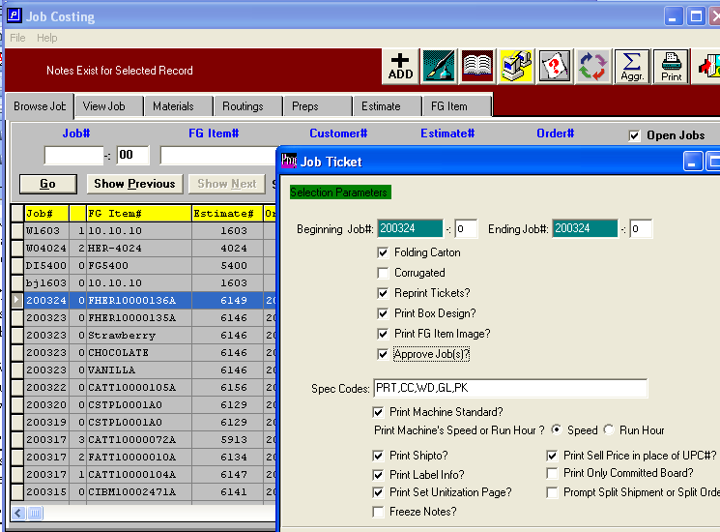

The job will appear in J-U-2, meaning it is ready printing in production.
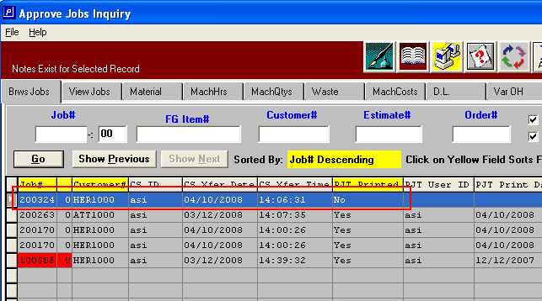

The job must be printed in J-U-2 to get the final production approved job card.
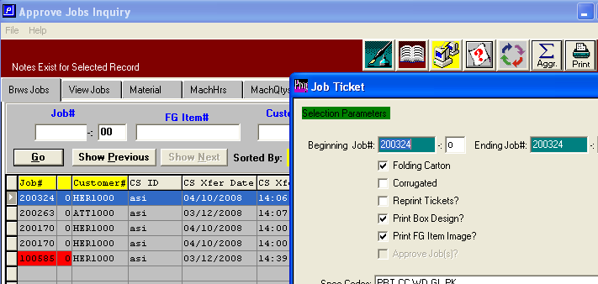

When printed from J-U-2 the “Production Job Ticket (PJT) Printed” field is set to “yes”.
